**Function definition**

Signature, purpose, and examples

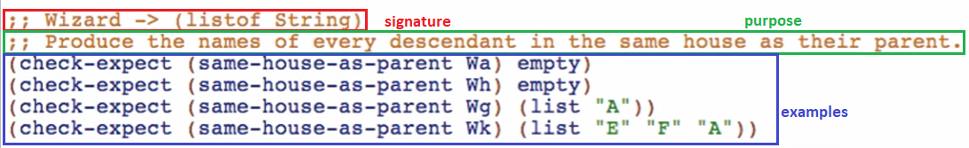

Template

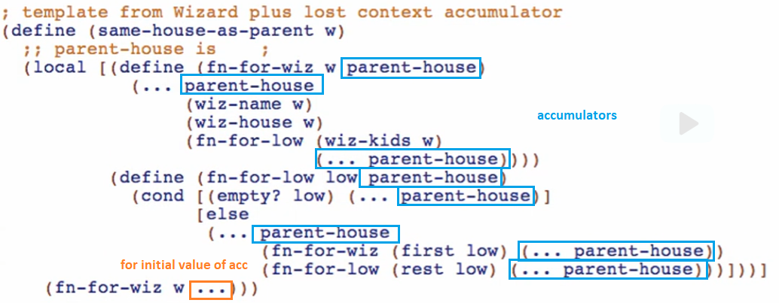

When adding accumulator to MUTUALLY recursive functions, it needs to be added to ALL of the functions

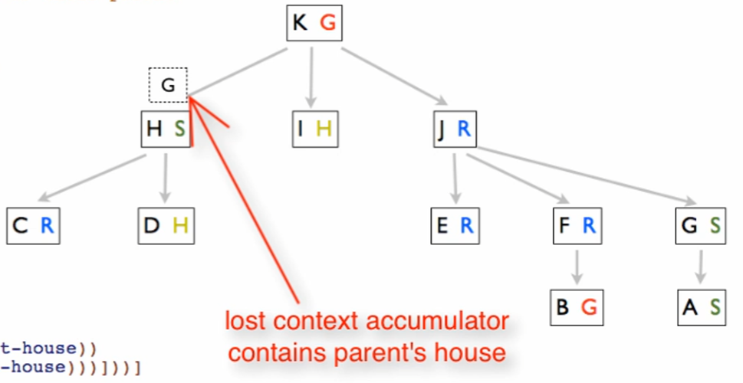

**Filling in the Accumulator definition**

*Type*



*Purpose*





*Examples*

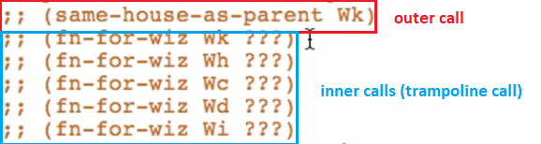

Note that we only use fn-for-wiz but it is not always the case. Sometimes we also need the function mutually recursive to it (fn-for-low) when determining examples for accumulators

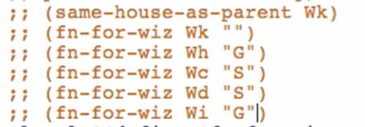

**Code body**

Doing the filtering stuff first before the accumulator

For fn-for-wiz

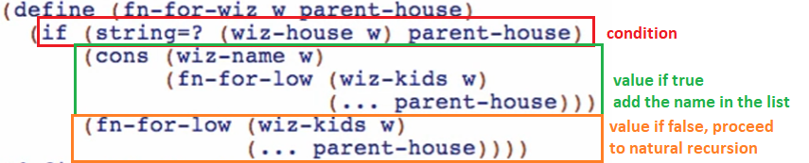

For fn-for-low

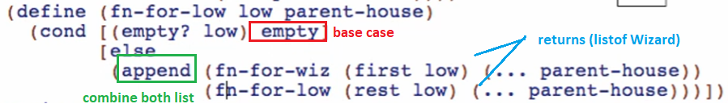

Doing the accumulator

Initial value:

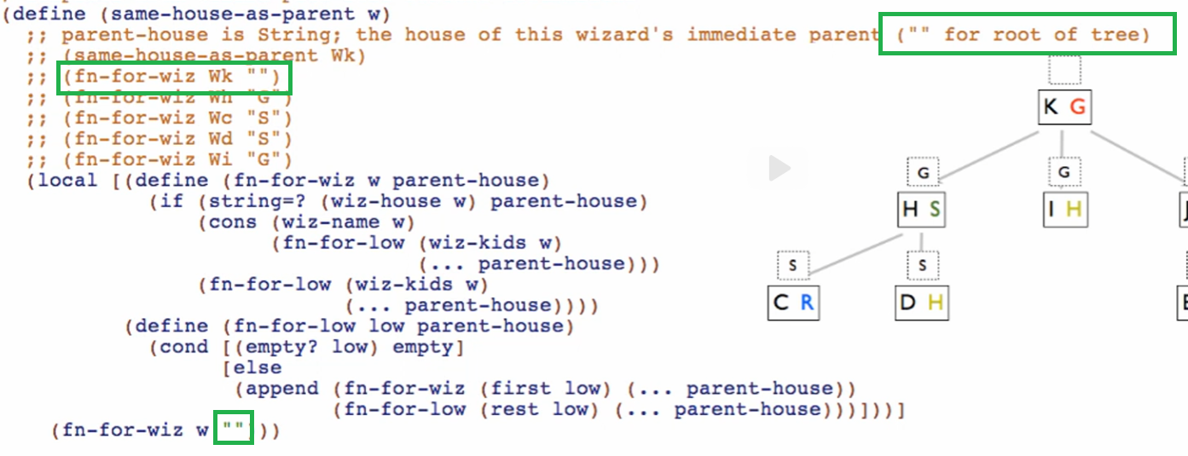

fn-for-wiz

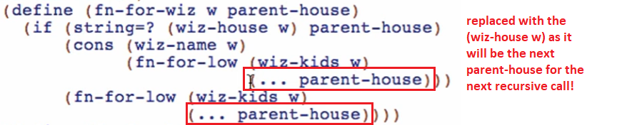

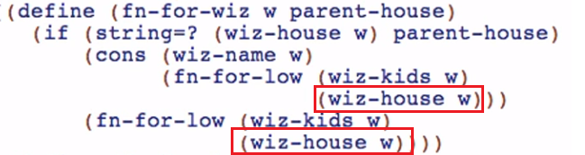

fn-for-low

